## Problem 3 – Digits

### You are given a matrix of digits. The matrix contains some patterns that form digits. Your task is to find these digits and calculate their sum:

The digit patterns are as follows:

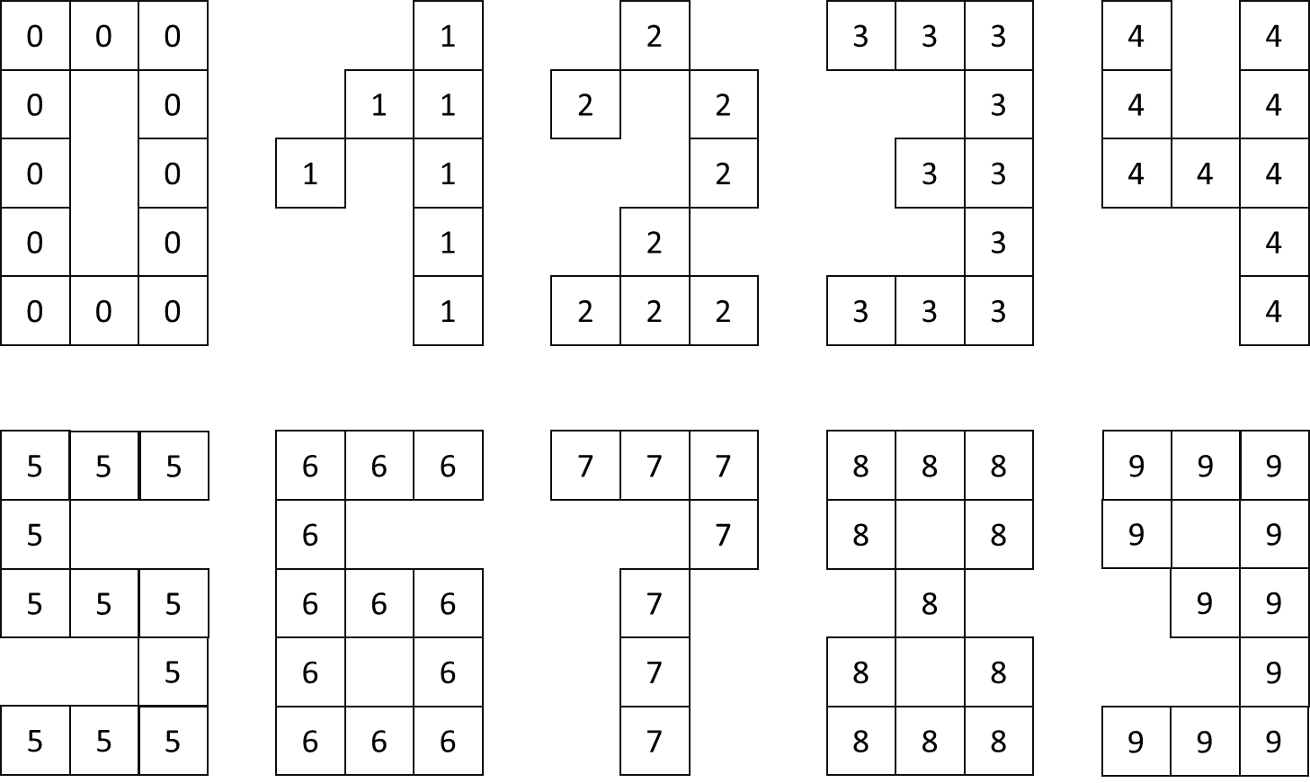Each digit patterns is formed by the same digit:

* The one-digit pattern is formed from cells with the digit one
* The nine-digit pattern is formed from cells with the digit nine
* Etc…

### The size of the patterns is constant and always has the given form.

### Example:

### The digit patterns are marked in green, red and blue

Four digit patterns are found – twice one-digit, one seven-digit and one four-digit pattern.

The sum is 1 + 1 + 4 + 7 = **13**

### Input

On the first line of the console you will find the number N – the number of rows and columns of the matrix

On the next N lines you will find exactly N digits, separated by a space. These are the digits of the matrix.

The input data will always be valid and in the described format. There is no need to check it explicitly.

### Output

The output data consists of a single line. It should contain the sum of all the digit patterns in the matrix

### Constraints

* **N** will always be **greater or equal to 5** and **less or equal to 1250**
* The values in the matrix will always be **digits**
* Allowed working time for your program: **0.3** seconds.
* Allowed memory: **32 MB**.

### Examples

|  |  |  |
| --- | --- | --- |
| **Input** | **Output** | **Explanation** |
| 5  1 1 1 1 1  1 1 1 1 1  1 1 1 1 1  1 1 1 1 1  1 1 1 1 1 | 3 | The one-patern is found three times.  The sum is 1+1+1 = **3** |

|  |  |  |
| --- | --- | --- |
| **Input** | **Output** | **Explanation** |
| 7  9 9 9 2 2 2  9 9 9 2 2 2  9 9 9 2 2 2  9 9 9 2 2 2  9 9 9 2 2 2  9 9 9 2 2 2 | 22 | The nine-pattern is found twice and the two-pattern is also found twice.  The sum is 9 + 9 + 2 + 2 = 22 |

|  |  |  |
| --- | --- | --- |
| **Input** | **Output** | **Explanation** |
| 8  3 2 1 1 2 3 0 1  2 1 1 9 7 6 4 0  1 4 1 7 7 7 5 1  2 4 1 4 2 7 1 1  3 4 1 4 7 1 3 1  0 4 4 4 7 4 5 1  5 8 2 4 7 3 2 1  1 2 7 4 9 2 1 8 | 13 | This is explained in the example above |